PPT

Page1-Data & Preprocessing

Data Source: JD.com camera reviews

Four Brands: Canon, Fujifilm, Nikon, Sony

Key Fields:
Field | Description
user_id | Anonymized user identifier
order_date | Date when the order was placed
order_comment | User's written review text
product_detail | Camera model and configuration
brand | Brand name (Canon/Fujifilm/Nikon/Sony)
- Preprocessing Steps:
Operation | Purpose
Deduplication | Remove duplicate records
Missing Value Handling | Exclude records with empty order_comment
Brand Filtering | Keep only Fujifilm, Canon, Nikon, Sony
Text Cleaning | Strip special characters, emojis, irrelevant symbols (【】, *, etc.)
Chinese Word Segmentation | Use Jieba to segment continuous text into meaningful words
Stop Word Removal | Filter out low-semantic words (的, 了, 也, 真的)

(口述：First, let me introduce our data and research methods. We collected camera review data from JD.com, focusing on four major brands: Canon, Fujifilm, Nikon, and Sony. The main fields we're working with are user_id, order_date, the actual review tex, product_detail, and brand name. For preprocessing, we applied a standard pipeline including deduplication, missing value handling, brand filtering, text cleaning, Chinese word segmentation using Jieba, and stop word removal. These steps ensured clean, structured data ready for our topic classification and sentiment analysis tasks. These steps ensured clean, structured data for our modeling and analysis.)

Page2-Topic Classification
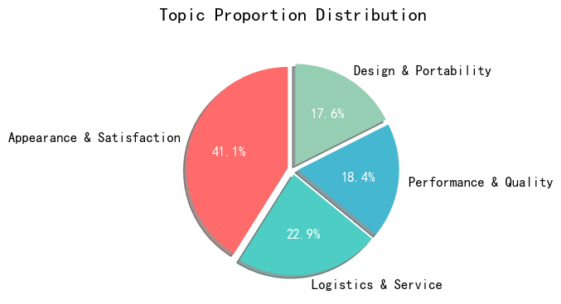
- Appearance & Satisfaction: Subjective satisfaction drives brand reputation
- Performance & Quality: Core performance matters for professional users
- Design & Portability: Key consideration for entry-level buyers
- Logistics & Service: Non-product factors influence purchase decisions

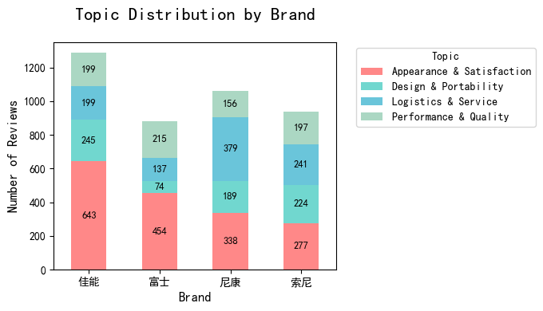
Canon: Appearance & Satisfaction-High overall satisfaction
Fujifilm: Performance & Quality-Performance is its most recognized label
Nikon: Logistics & Service-After-sales service is the key differentiator
Sony: Most balanced distribution-Consistent across all dimensions
(口述：Now let me walk you through our topic classification results. Through LDA topic model optimization, we determined that the optimal number of topics is four. As shown in the chart, the largest by far is Appearance & Satisfaction, accounting for over 41% of all comments. This tells us that subjective satisfaction is the core driver of brand reputation. Performance & Quality comes next at nearly 23%, which is especially important for professional and advanced users. Design & Portability matters for entry-level buyers, while Logistics & Service reminds us that non-product factors like delivery and after-sales also influence purchase decisions.
For brand distribution: each brand has a distinct strength. Canon leads in Appearance & Satisfaction with 643 comments, and its distribution is very balanced, making it a reliable all-rounder. Fujifilm stands out in Performance & Quality, receiving the highest number of comments among all four brands. This shows that performance is Fujifilm's most recognized label. Nikon dominates Logistics & Service, far ahead of others, which suggests its after-sales support is a key competitive advantage. Sony has the most balanced distribution across all topics, meaning users consistently discuss it across every dimension without any extreme weakness.)

Page3：Comparison of Topic Classification Models
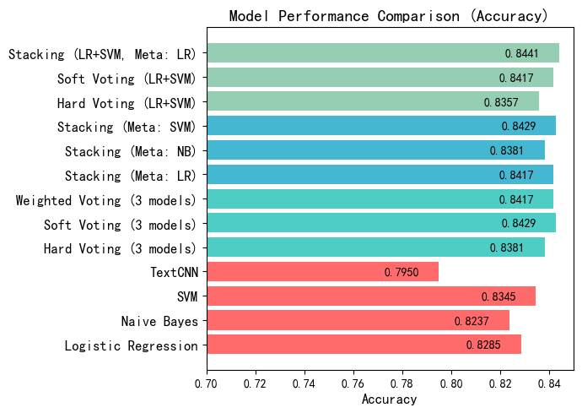
- Ensemble learning outperforms single models
- Stacking achieves highest accuracy for topic classification
- SVM is the best single model for camera review text
- Deep learning (TextCNN) underperforms due to short text nature

(口述：Next, to further underpin the digital marketing initiatives of brands, we develops a topic classification model and generalizes its classification capability to unseen data. This enables high-precision automated classification of camera review topics, supporting brands in building a real-time review monitoring system to quickly capture shifts in consumer discussion hotspots and demand trends. We compared multiple models, and the best performer is the Stacking ensemble, combining Logistic Regression and SVM, achieving over 84% accuracy. Ensemble methods consistently outperform single models. Among single models, SVM does the best at about 83.5%, while deep learning—TextCNN—actually underperforms. We believe this is because camera reviews are mostly short sentences, so deep learning's complex feature extraction doesn't add much value and may even overfit.)

Report

3.1 Data sources, data cleansing and pre-processing
The dataset was collected from JD.com, one of China’s largest e-commerce platforms, focusing on camera products. We specifically target four major camera brands: Fujifilm, Canon, Nikon, and Sony. These brands represent a wide range of user-generated textual content, including product reviews and order comments, making the dataset highly suitable for marketing analysis.
Review records were collected covering multiple camera models and user interactions across the four brands. Each record contains the following core fields:
Field | Description
user_id | Anonymized user identifier
order_date | Date when the order was placed
product_detail | Specific camera configuration (e.g., model and color)
order_comment | User’s written feedback or review text
product_title | Official product title on JD.com
brand | Brand name of the product (Fujifilm / Canon / Nikon / Sony)
The figure below presents a sample of the raw data:
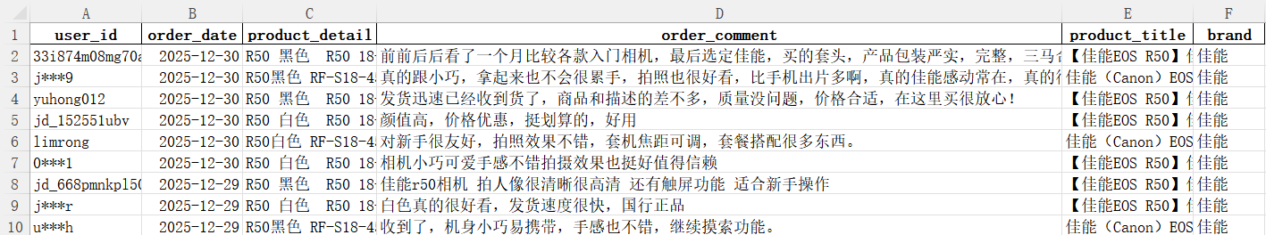
To ensure data quality and support downstream text mining tasks — including brand-level analysis, sentiment scoring, topic classification, and the final dashboard/chatbot integration — a multi-step preprocessing pipeline was applied:
- Deduplication
Duplicate review records (same user_id, order_date, and order_comment) were removed to avoid over-weighting the same feedback.
- Missing value handling
Records with empty or null order_comment fields were excluded, as the comment text is essential for sentiment and topic analysis.
- Brand filtering
Only reviews belonging to Fujifilm, Canon, Nikon, or Sony were retained, ensuring the analysis focuses on the four target brands.
- Text cleaning
Special characters, emojis, and irrelevant symbols (e.g., 【】, *, extra spaces) were stripped from the order_comment field to standardize the text format.
- Chinese word segmentation
The jieba library — a widely used Chinese segmentation tool — was employed to segment continuous review text into meaningful words .
- Stop word removal
Common stop words with little semantic value (e.g., “的”, “了”, “也”, “真的”) were filtered out, allowing subsequent analysis to focus on informative terms like “画质”, “续航”, “性价比”, and “推荐”.
After preprocessing, the cleaned text data was ready for downstream tasks, including topic classification, sentiment analysis, brand analysis and the construction of a dashboard and chatbot for interactive marketing insights.

4.1 Topic Classification

4.1.1 Overview of Research Methods
After completing preprocessing such as data cleaning, Chinese word segmentation, and stop word filtering on the JD camera comment data, this research carried out word cloud visualization analysis, LDA topic model modeling (completing optimal topic number optimization and topic annotation), machine learning model classification (Logistic Regression, Naive Bayes, SVM, etc.), ensemble learning method optimization (Voting Ensemble, Stacking Ensemble) and deep learning TextCNN model modeling in turn. Finally, the classification effects of all models were quantitatively compared to screen out the optimal topic classification model. The whole research process ensures the consistency of data processing and controllable randomness of model training to guarantee the reliability of results.

4.1.2 Core Analysis Conclusions

(1) LDA Topic Model: Mining Four Core User Discussion Topics
Through the optimization of the LDA topic model, the optimal number of topics for the comment data is determined to be 4. The topic naming and interpretation are completed based on the characteristics of topic keywords. The four topics cover the full-dimensional feedback of users on camera products and services, and the core characteristics and commercial value of each topic are as follows:

- Design & Portability: The core keywords are effect, imaging, appearance, portability, compact, etc. It is the core discussion point of users on the physical attributes and basic use experience of camera products, reflecting the brand's competitiveness in hardware aspects such as product appearance design and portability optimization, and is an important consideration for entry-level users when purchasing cameras.
- Performance & Quality: The core keywords are video, focusing, image quality, shooting, operation, etc., and the brand word "Sony" appears, indicating that Sony has the highest mention rate in users' performance discussions. This topic focuses on the core functional performance of cameras, is the focus of professional and advanced users, and is also a key dimension for brands to create product differentiation.
- Appearance & Satisfaction: Accounting for 41.08%, it is the topic with the highest proportion among the four major topics. The core keywords are like, satisfied, appearance, recommend, etc., reflecting users' comprehensive evaluation and emotional tendency towards cameras. The high proportion indicates that users' subjective satisfaction is the core content of comments and a direct reflection of brand reputation building.
- Logistics & Service: The core keywords are logistics, customer service, JD.com, genuine product, received, etc., and the brand word "Nikon" appears at the same time, indicating that Nikon's logistics and after-sales service are the focus of user discussions. This topic reflects the user experience of e-commerce platform services and brand after-sales supporting facilities, and is an important non-product factor affecting users' purchase decisions and repurchase intentions.

Brand Topic Distribution: Significant Differentiation in the Focus of User Discussions for Each Brand
The comment distribution of each brand under the four major topics shows significant differences, which directly reflects the differentiated characteristics of the cognitive positioning and core competitiveness of different brands in the user's mind:

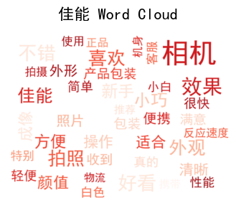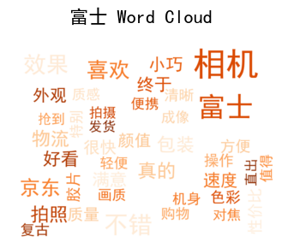
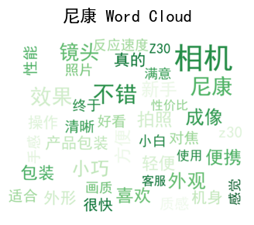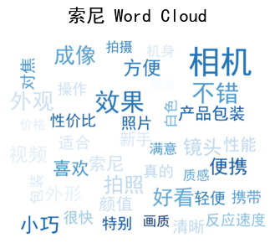
- Canon: Ranked first among the four major brands with 643 comments under the topic of Appearance & Satisfaction, and the comment distribution of the four major topics is relatively balanced with the comment volume of each dimension at a high level. It reflects that Canon's products have excellent comprehensive experience performance, high overall user satisfaction, no obvious shortcomings in brand reputation, and are a benchmark brand with balanced performance in all dimensions.
- Fujifilm: Received the highest number of comments among all four brands in Performance & Quality, with 215 comments, exceeding Canon (199), Nikon (156), and Sony (197). This indicates that users recognize Fujifilm's core performance capabilities, making performance quality the brand's most prominent feature in user discussions.
- Nikon: The number of comments under the topic of Logistics & Service reached 379, far exceeding other brands and its own other topics, becoming the primary discussion point of Nikon users. It shows that Nikon has outstanding user experience performance in e-commerce logistics distribution, after-sales service guarantee and other links, which is the core differentiated competitiveness formed by the brand at the non-product level.
- Sony: Comment distribution across the four topics is the most balanced among all brands, with each topic receiving between 197 and 277 comments. This reflects that Sony maintains consistent user discussion across all dimensions without extreme polarization in any single area.

Model Performance Comparison
To underpin the digital marketing initiatives of brands, this study develops a topic classification model and generalizes its classification capability to unseen data. This enables high-precision automated classification of camera review topics, supporting brands in building a real-time review monitoring system to quickly capture shifts in consumer discussion hotspots and demand trends.
The classification effects (Accuracy, Weighted F1-score) of single machine learning models, ensemble learning models and deep learning TextCNN models are quantitatively compared, and the following core conclusions are drawn:
Model | Accuracy | Weighted F1
Logistic Regression | 0.8285 | 0.8281
Naive Bayes | 0.8237 | 0.8227
SVM | 0.8345 | 0.8353
TextCNN | 0.7950 | 0.7939
Soft Voting (LR+SVM) | 0.8417 | 0.8424
Hard Voting (3 models) | 0.8381 | 0.8377
Soft Voting (3 models) | 0.8429 | 0.8433
Weighted Voting (3 models) | 0.8417 | 0.8421
Stacking (Meta: NB) | 0.8381 | 0.8388
Hard Voting (LR+SVM) | 0.8357 | 0.8345
Stacking (LR+SVM, Meta: LR) | 0.8441 | 0.8447
Stacking (Meta: SVM) | 0.8429 | 0.8435
Stacking (Meta: LR) | 0.8417 | 0.8424



- Ensemble learning models perform significantly better than single models: The accuracy and F1 values of most ensemble learning models are higher than those of single machine learning models such as Logistic Regression, Naive Bayes and SVM, and also higher than the deep learning TextCNN model (accuracy 0.7950). It indicates that the way of multi-model fusion can effectively make up for the classification shortcomings of single models and improve the accuracy and stability of topic classification.
- Stacking (LR+SVM, Meta: LR) is the optimal model: This model has become the optimal solution among all models with 84.41% accuracy and 84.47% weighted F1 value, and is the best model for topic classification of camera comment text. This model combines the advantages of Logistic Regression and SVM, completes model fusion through a secondary Logistic Regression meta-learner, and has the strongest adaptability to feature capture of comment text and topic classification.
- SVM performs the best among single models: Among single machine learning models, the SVM model has the highest accuracy (83.45%) and F1 value (83.85%), which is better than Logistic Regression and Naive Bayes, indicating that the nonlinear fitting ability of the kernel function method to text features is more suitable for the text data features of camera comments.
- TextCNN model performance is relatively weak: The classification effect of the deep learning TextCNN model is the worst among all models. It is speculated that the reason is that camera comment texts are mostly short sentences with relatively simple feature dimensions. The complex feature extraction ability of the deep learning model is difficult to exert its advantages, and there is a risk of overfitting instead.

